**ClereMed – Linking Pre-Screening and Screening Game Results to Recommendations**

Recommendations for pharmacists following ClereMed pre-screening and screening game are as follows:

1. Use the standard label (9-12 pt font)
2. Print a second (large) label
3. Colour/# code
4. Recommend a follow-up with an optometrist
5. Use compliance packaging
6. Do not tape
7. Discuss; decision based on judgment of pharmacist

**Table 1.** Links between ClereMed pre-screening and screening game results and recommendations

|  |  |
| --- | --- |
| **Pre-Screening Question** | **Recommendation** |
| **Do you use…** |  |
| Glasses or contacts? | n/a |
| Bifocals or reading glasses? | n/a |
| A magnifier? | n/a |
| Large print material? | 7 if answer is ‘yes’ and the task is completed with 9-12 pt font |
| **Do you have difficulty reading…** |  |
| Prescription labels? | 7 if answer is ‘yes’ and the task is completed with 9-12 pt font |
| Non-prescription labels? | 7 if answer is ‘yes’ the task is completed with 9-12 pt font |
| Worn prescription labels? | 7 if answer is ‘yes’ to determine an appropriate solution, especially if the participant also has difficulty with glossy papers |
| Glossy papers (magazines)? | 6 |
| **Screening Results** |  |
| Able to complete task using 9-12 pt (standard) font | 1 |
| Requires 18 pt font to complete the task | 2, 3, 4 |
| Cannot complete the task | 4, 5 |

**Figure 1.** Flow chart linking ClereMed pre-screening and screening test results to recommendations

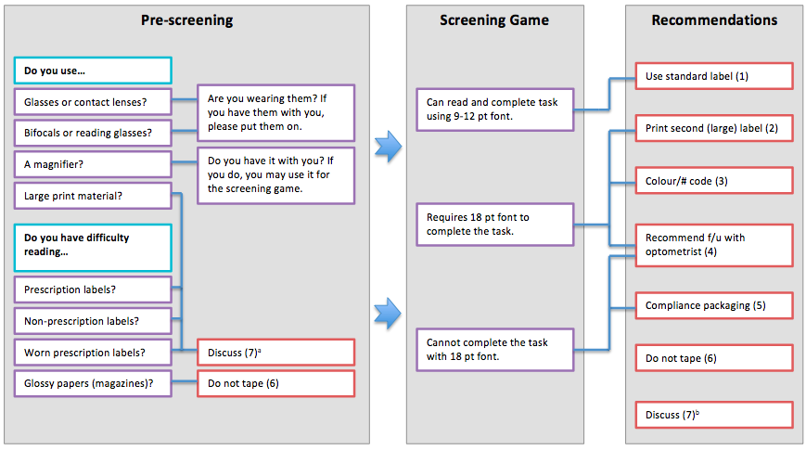

aAlthough a participant may report requiring large print material or having difficulty reading prescription or OTC labels and/or worn labels, screening results may indicate that the participant has the ability to complete the screening game using 9-12 pt font. In this case, the pharmacist should discuss the results with the participant and decide on the best option.

bWhen applicable based on screening results, prescription(s), or disease condition(s) (e.g., if participant reports difficulty with both worn and glossy labels, the benefits and risks of taping the label should be discussed).